**ANALYSIS OF SUPERMARKET SALE DATA USING MICROSOFT EXCEL**

**Description:**

Using MS Excel on supermarket sale dataset to do the following.

1. Using Pivot table Timeline and slicer to indicate the months, product line and gender of all the dataset.
2. calculating the sum of quantity, Units price, gross income and cost of goods sold within the period of the dataset for the supermarket.
3. Getting the sum of quantity of each mode of payment of paying representing it in percentage and a chart.
4. Calculation the sum quantity of sale and gross income by product and representing chart.
5. Calculating sum quantity of sale and gross income by branch and representing them in chart.
6. Dashboard.

Using Pivot table Timeline and slicer to indicate the months, product line and gender of all the dataset.

calculating the sum of quantity, Units price, gross income and cost of goods sold within the period of the dataset for the supermarket.

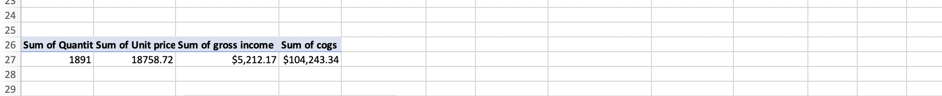

Getting the sum of quantity of each mode of payment of paying representing it in percentage and a chart.

Calculation the sum quantity of sale and gross income by product and representing chart.

k Calculating sum quantity of sale and gross income by branch and representing them in chart.

DASBOARD

